CSA1617 DWDM LAB PROGRAMS

NANDHINI S 192311005

1. Approximate Median

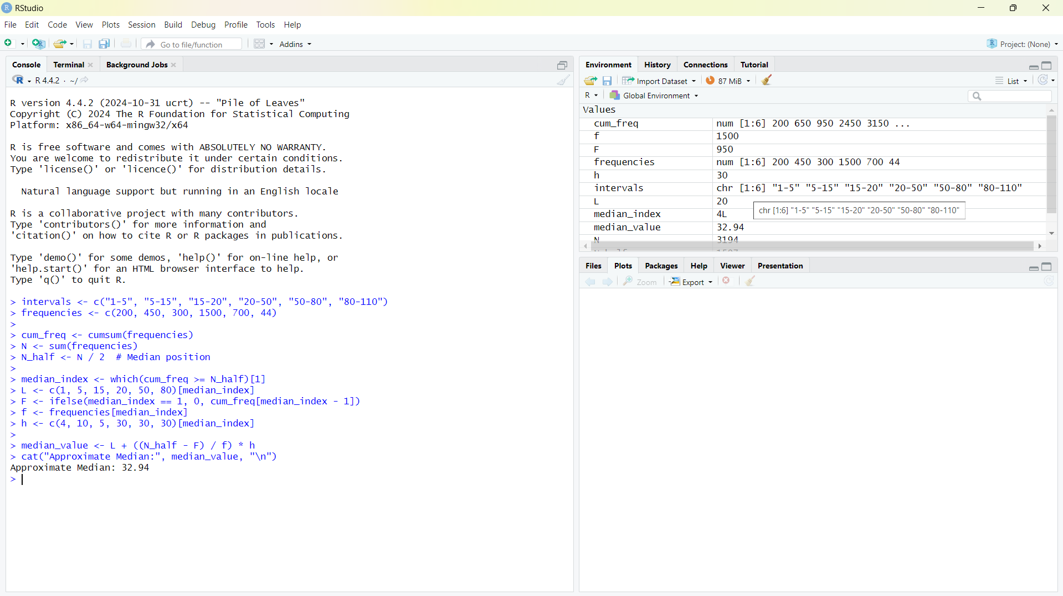

1. Mean median mode iqr

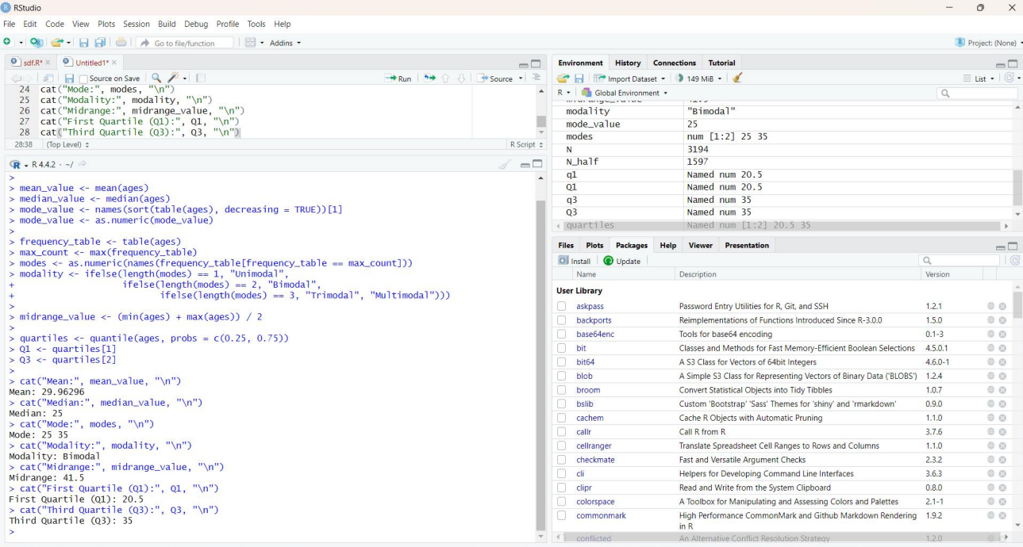

1. Minmax and z

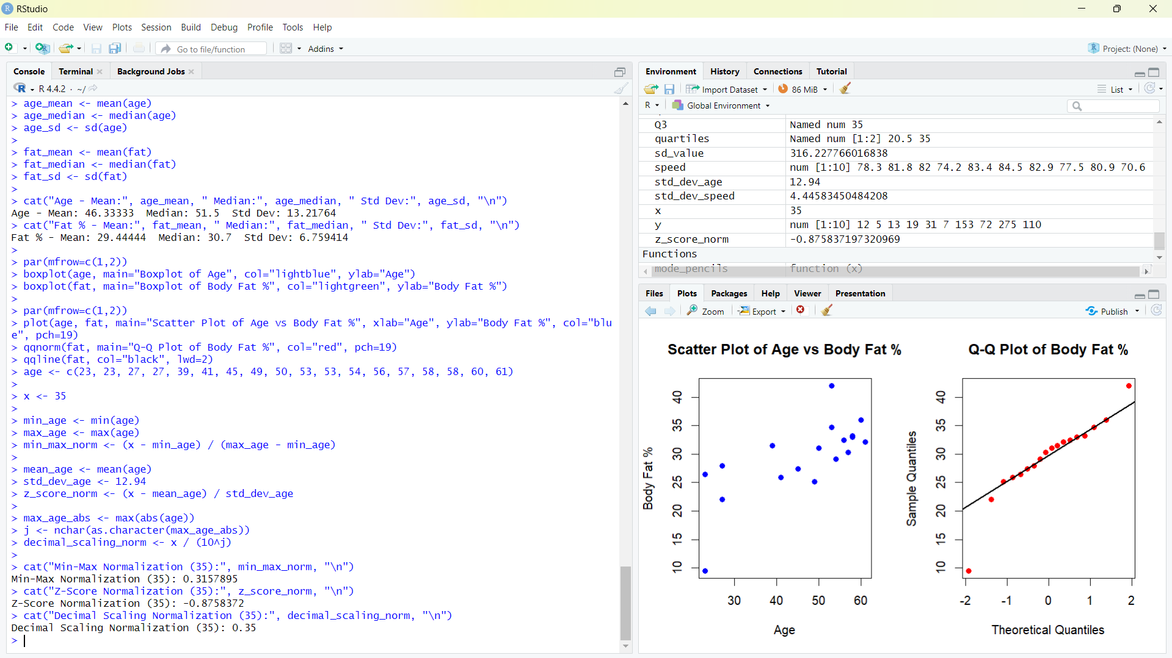

1. Smoothing , mean , median , boundaries

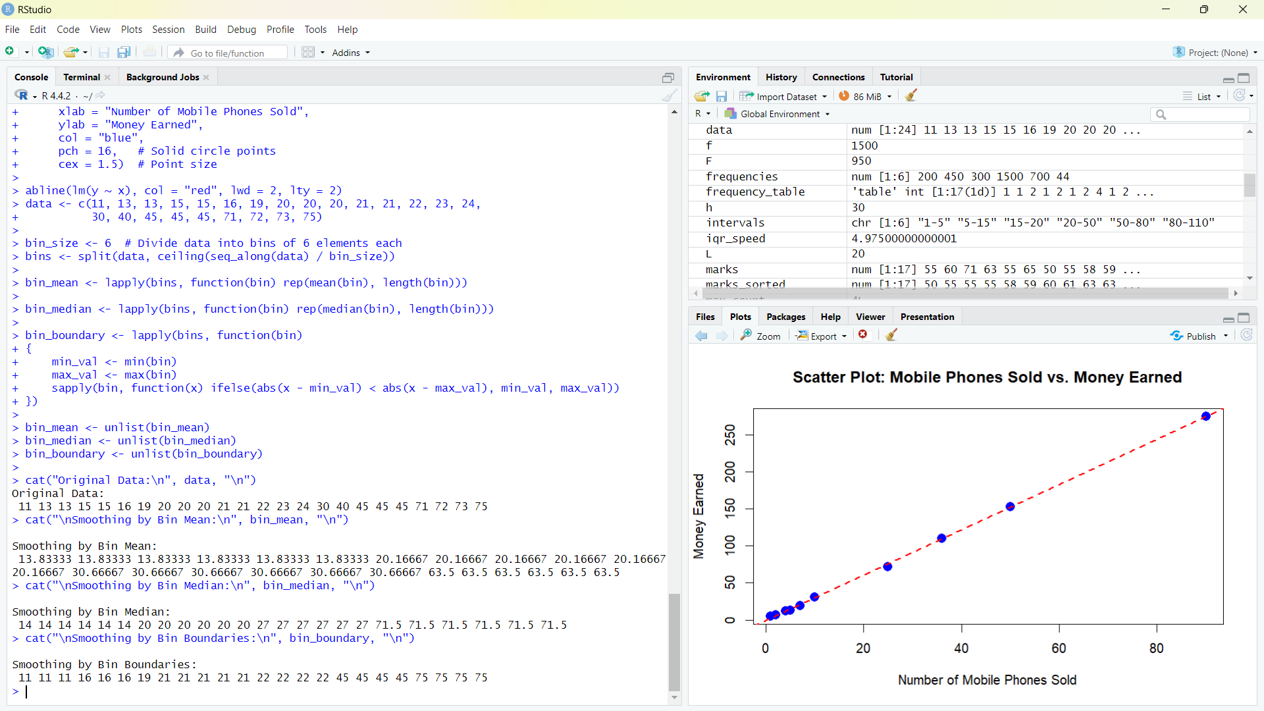

1. mean median mode

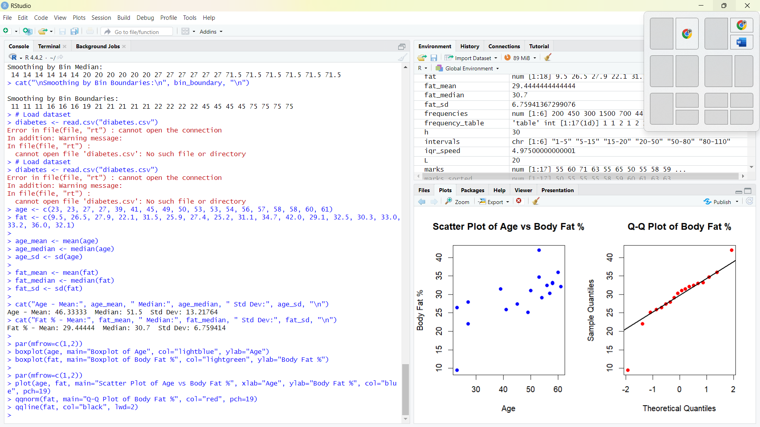

1. MINMAX Z DECIMAL

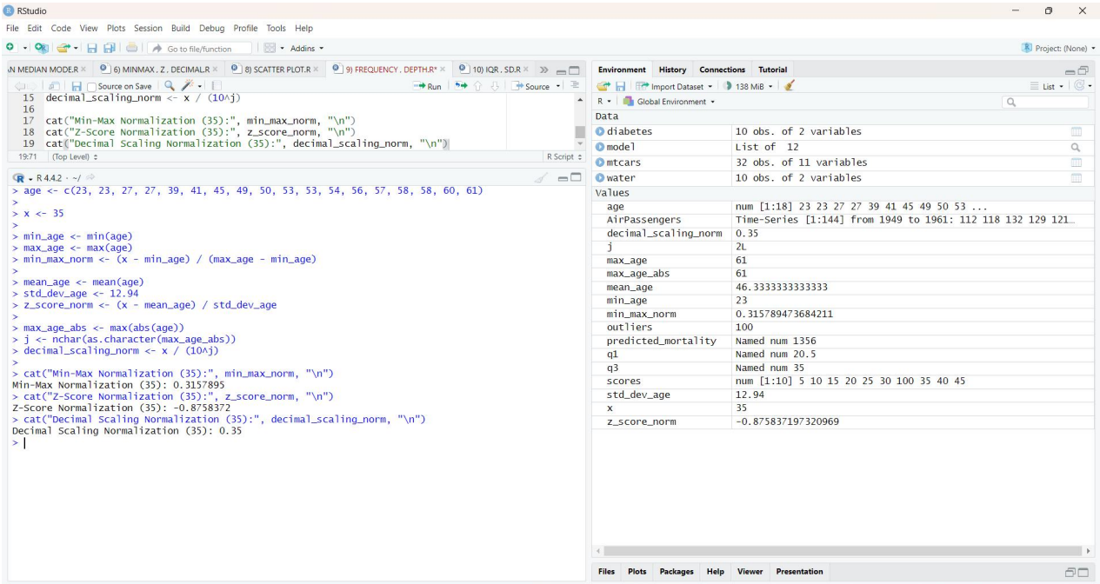

1. Mean median mode

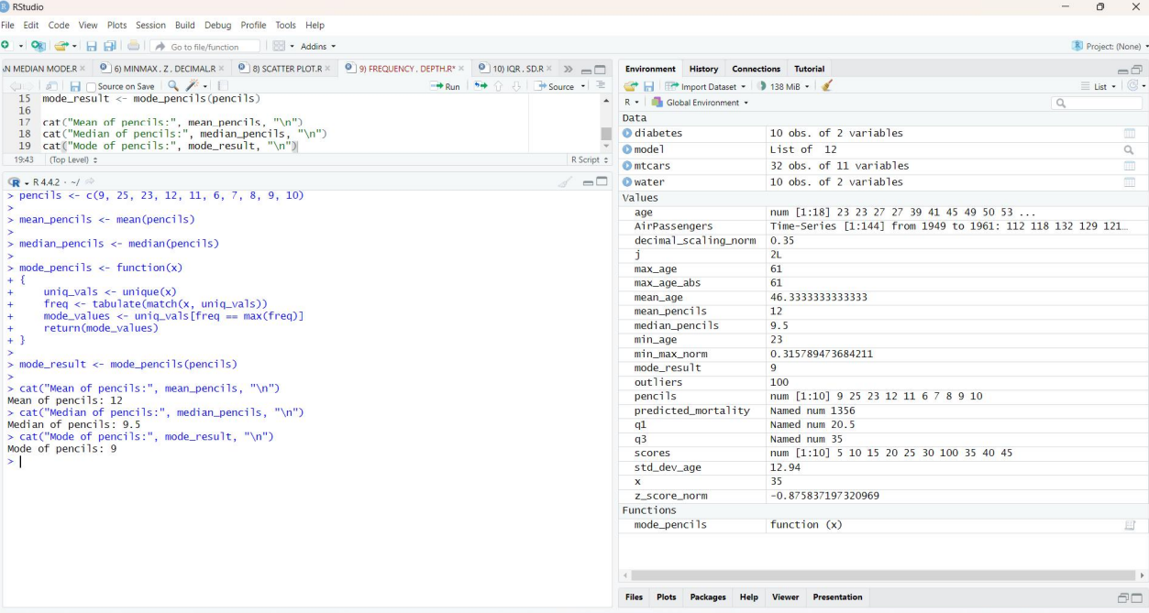

1. SCATTERPLOT

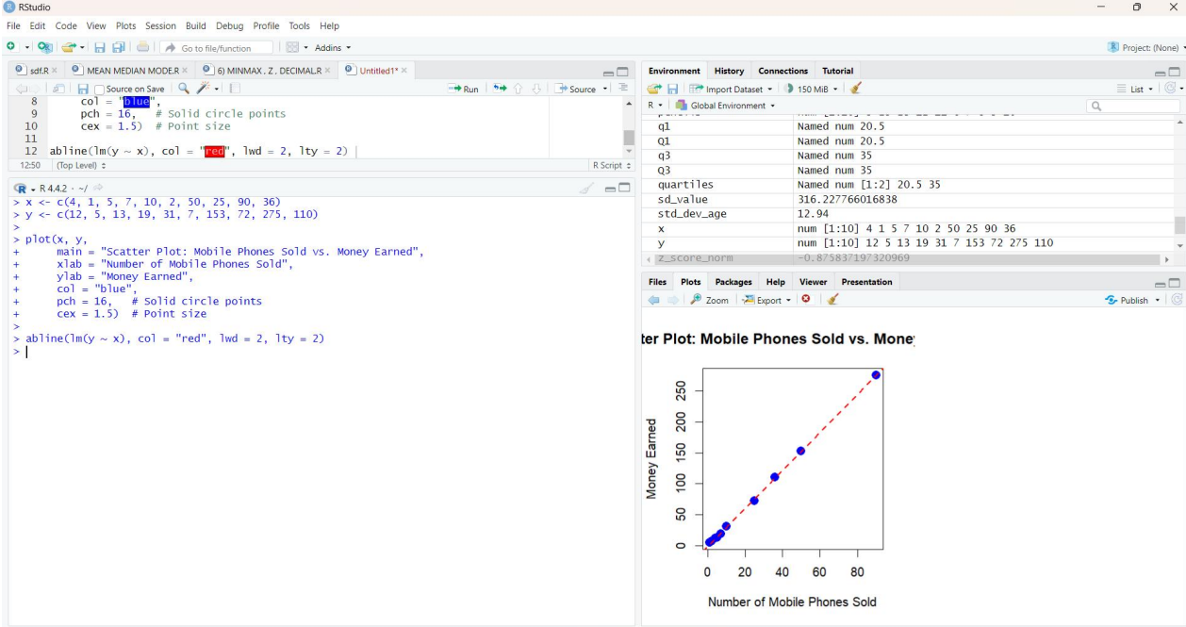

1. FREQUENCY , DEPTH

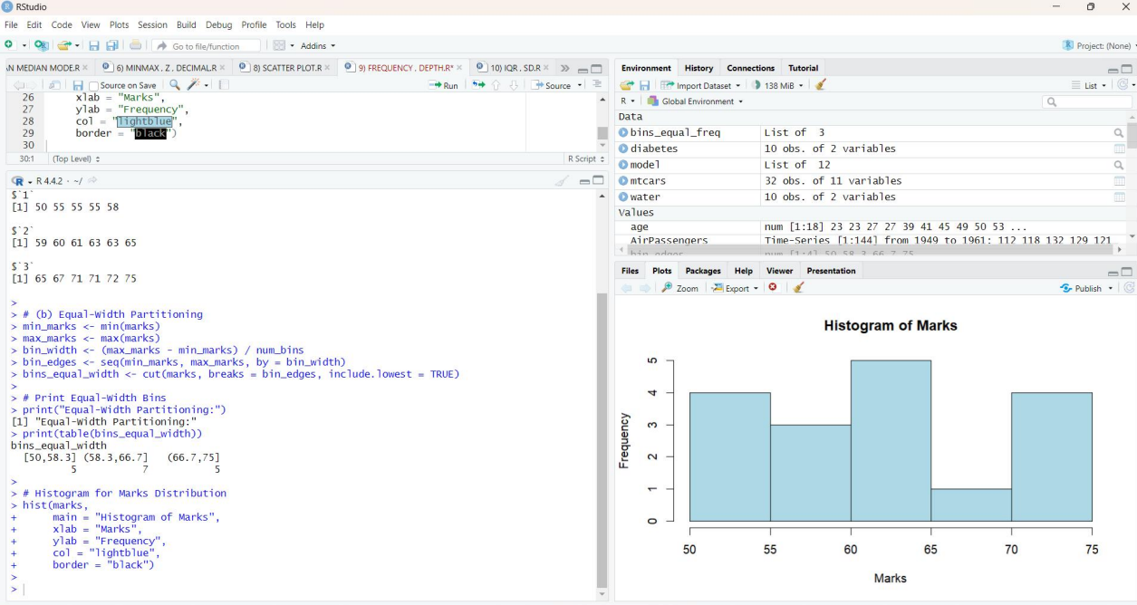

1. IQR, SD

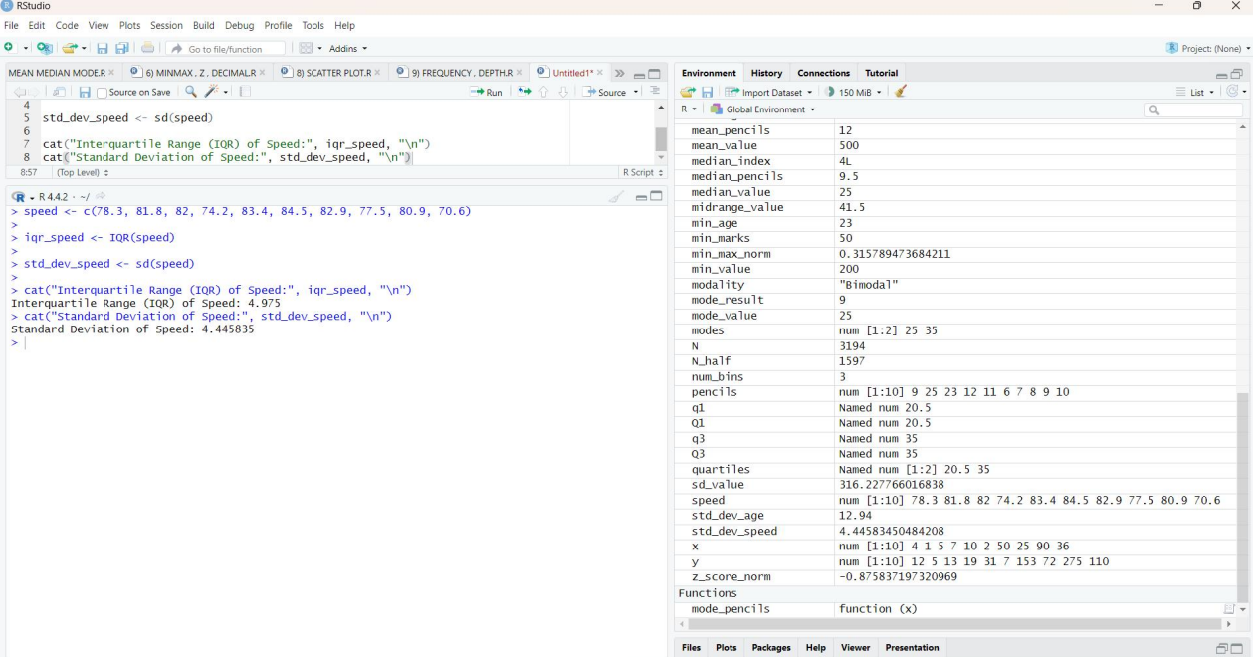

1. Q1,Q3

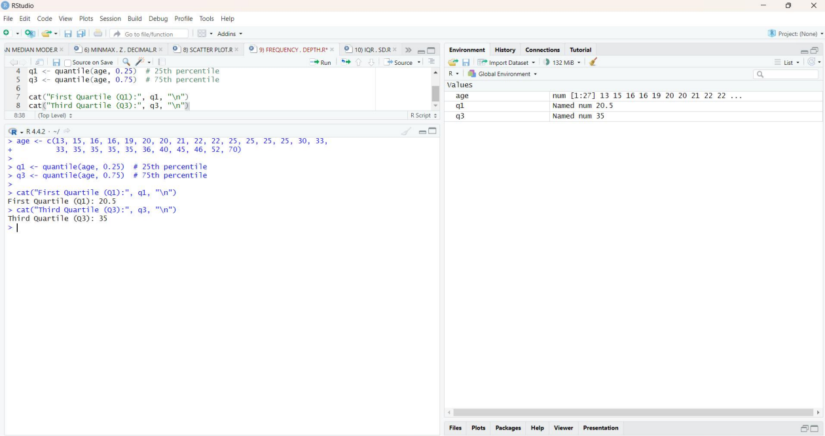

1. HISTOGRAM

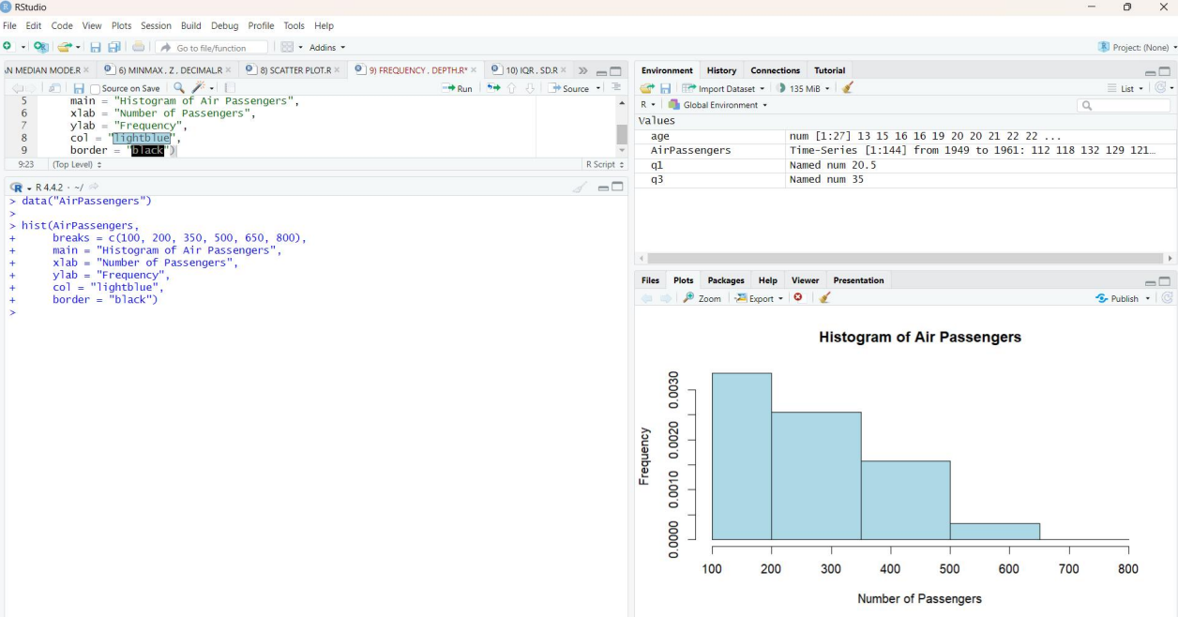

1. LINECHART

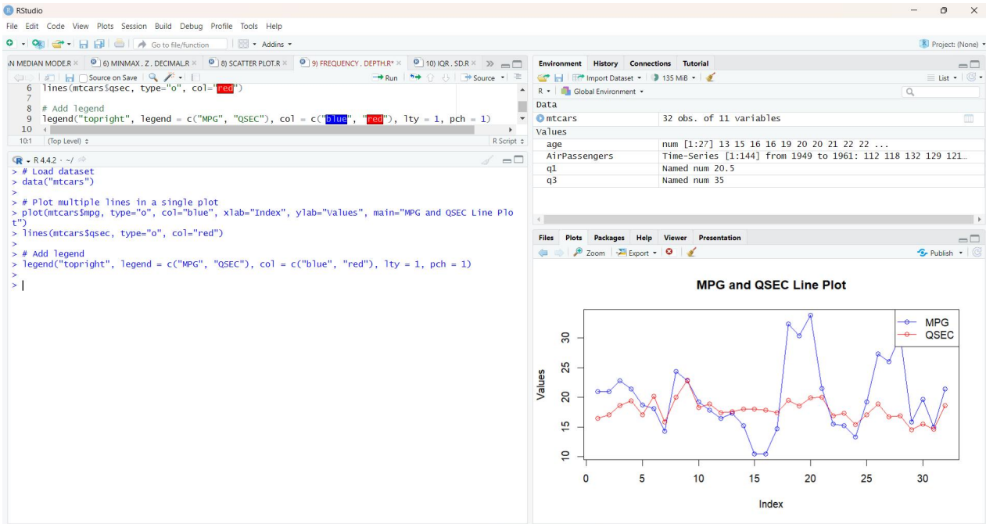

1. LINEAR REGRESSION

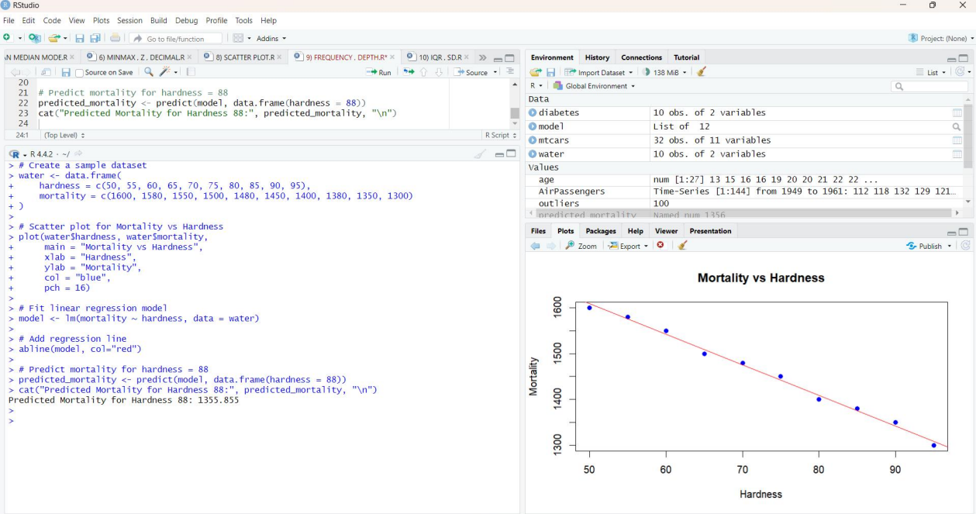

1. BOXPLOT OD MGP VS CYL

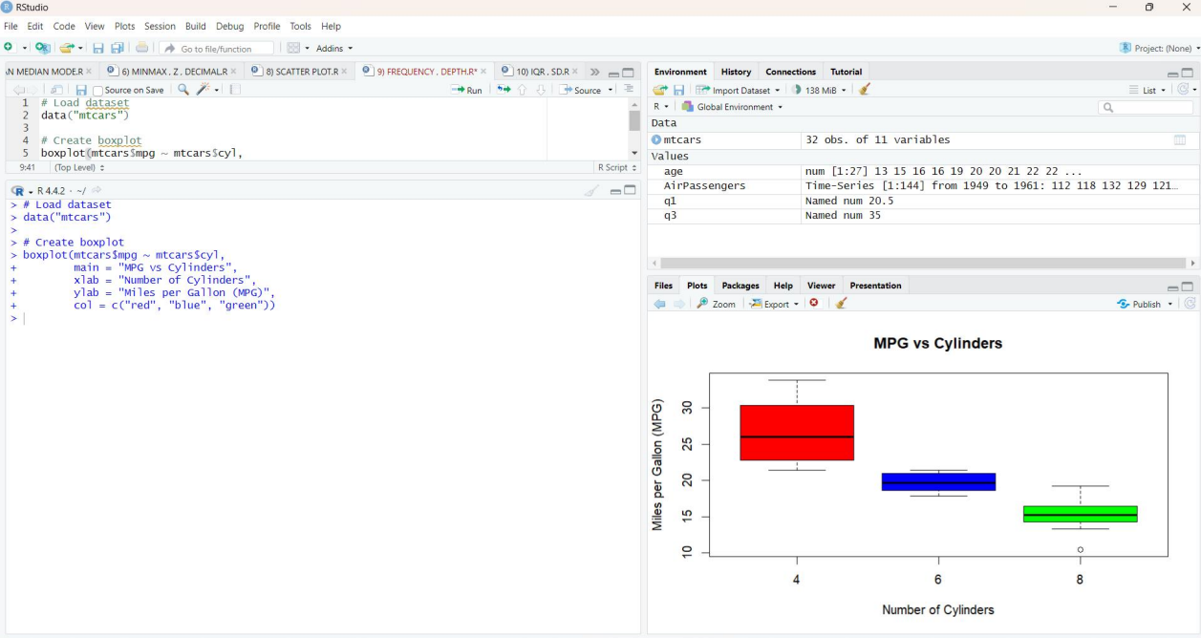

1. BOXPLOT OF TENNIS PLAYER

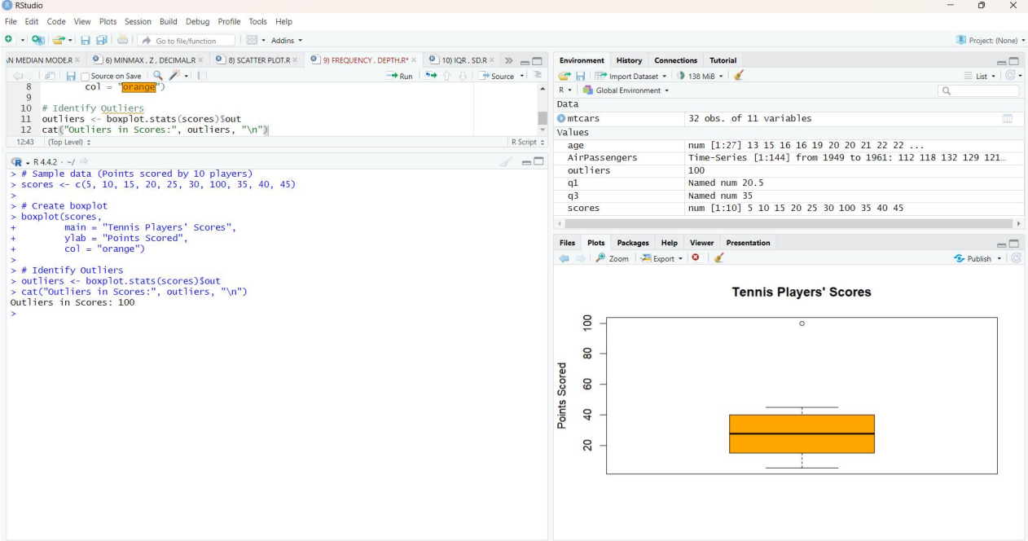

1. SCATTER AND BOX CHART

